OSKAR memo XX:

The application of analytical time smearing.

# Introduction

OSKAR implements analytical time smearing of visibility samples for each correlator dump based on the equation:

[TODO]

This memo investigates the analytical time smearing performance of OSKAR by comparing simulations using analytical time smearing to those using an average of a large number of sub-intervals.

# Simulation configuration

Simulations were performed of a single snapshot observation with the July 2015 SKA1-Mid configuration of 197 antennas. Station beam effects were disabled and the simulation was performed in single polarisation Stokes-I mode using OSKAR 2.6.1.

The length of the snapshot observation was varied to take the following values 0.05s, 0.1s, 0.25s and 0.5s and the snapshot was either simulated as a single correlator dump or a series of shorter correlator dumps which have been averaged. The number of time steps within a correlator dump was varied to be 1, 10, or 1000 steps within the dump time.

* Telescope model:
  + ska1\_meerkat\_mid\_combined\_july\_2015.tm (197 antennas, ~157km maximum baseline)
  + Longitude: 21.442909 degrees
  + Latitude: -30.739475 degrees
  + Isotropic beam model
* Observation settings:
  + Frequency: 700.0 MHz
  + Channel bandwidth: 0.0 MHz
  + RA: -90.3545848760 degrees
  + Dec: -8.5711239906 degrees
  + Start time: 57086.113194 MJD UTC
  + Observation length: 0.05s, 0.1s, 0.25s, 0.5s
  + Snapshots per observation: 1, 10, or 1000.
* Sky model:
  + Single 1Jy source, +0.9 degrees in declination from the observation phase centre (i.e. Dec: -7.6711239906 degrees)

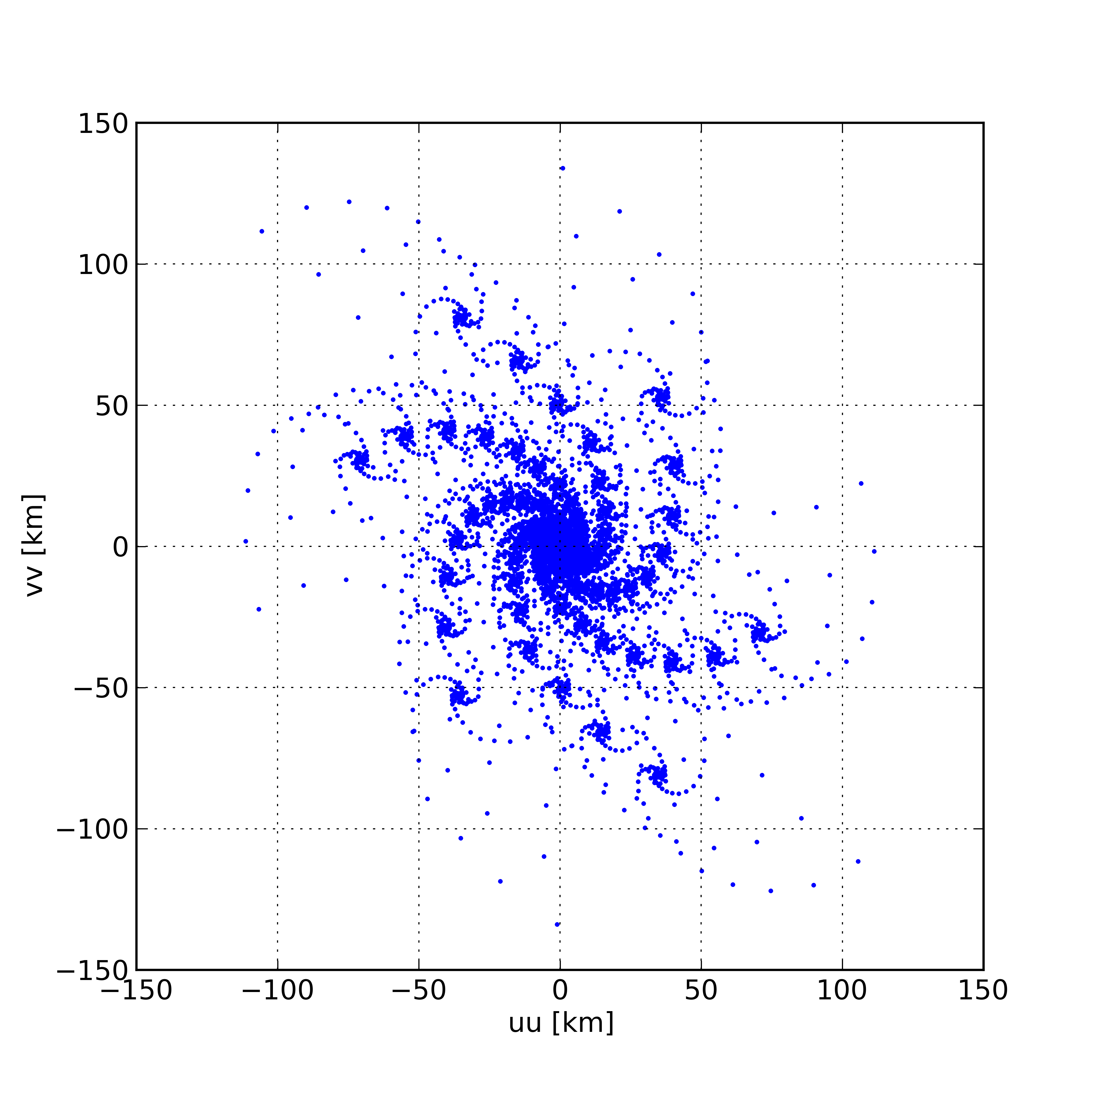

Figure : Snapshot uu-vv baseline distribution

## Measurement set averaging

Comparisons are made between a single correlator dump and (with and without analytical time smearing correction) and the same correlator dump formed by averaging a number of sub intervals. The sub-intervals were also simulated with and without analytical time smearing.

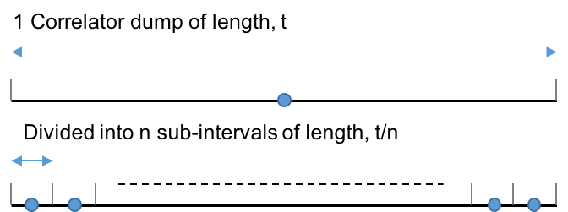

Figure : Averaging sub-intervals to form a correlator dump

# Results

Dirty images with a field-of-view of 0.02 degrees and 512 by 512 pixels where made centred on the source using CASA. Standard 2D imaging (no w-projection) was used. Figure 2 shows the dirty image produced from the simulation for a single snapshot. All subsequent results will show differences between images with using different methods to obtain time smearing.

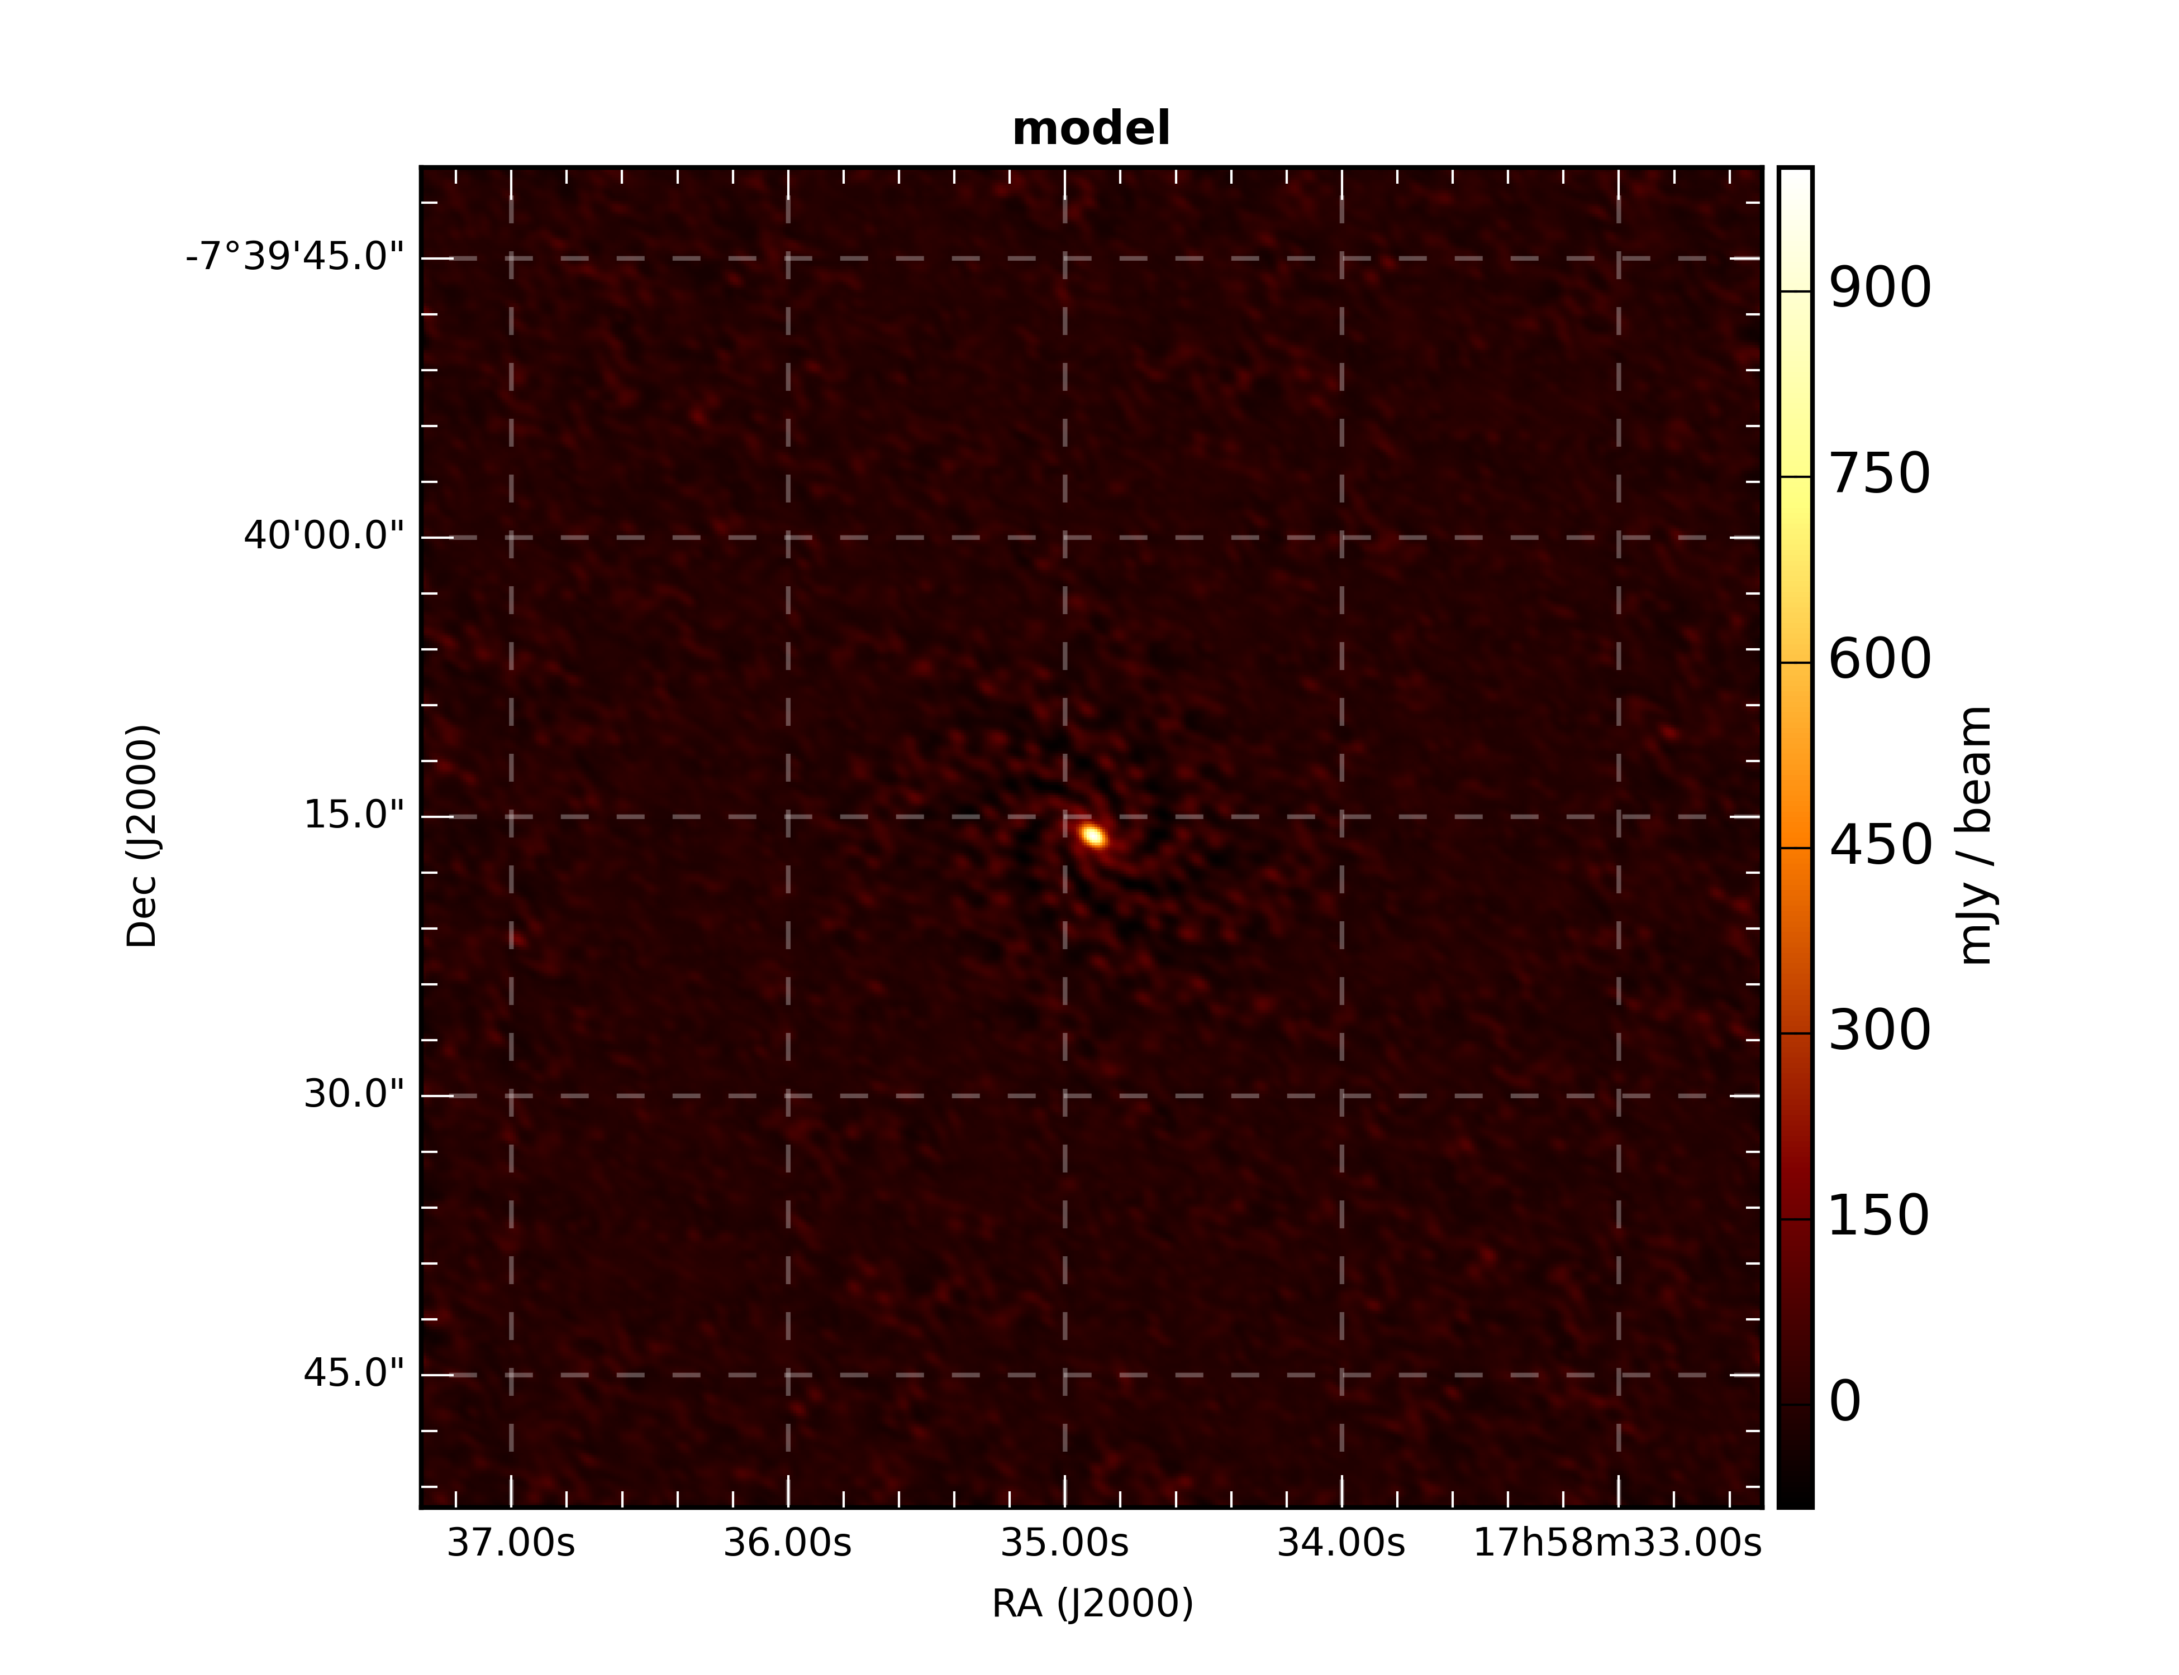

Figure : Dirty image centred on the source, 0.9 degrees from the observation phase centre.

## Simulation 1: 0.05 second correlator dump time

### 1 snapshot

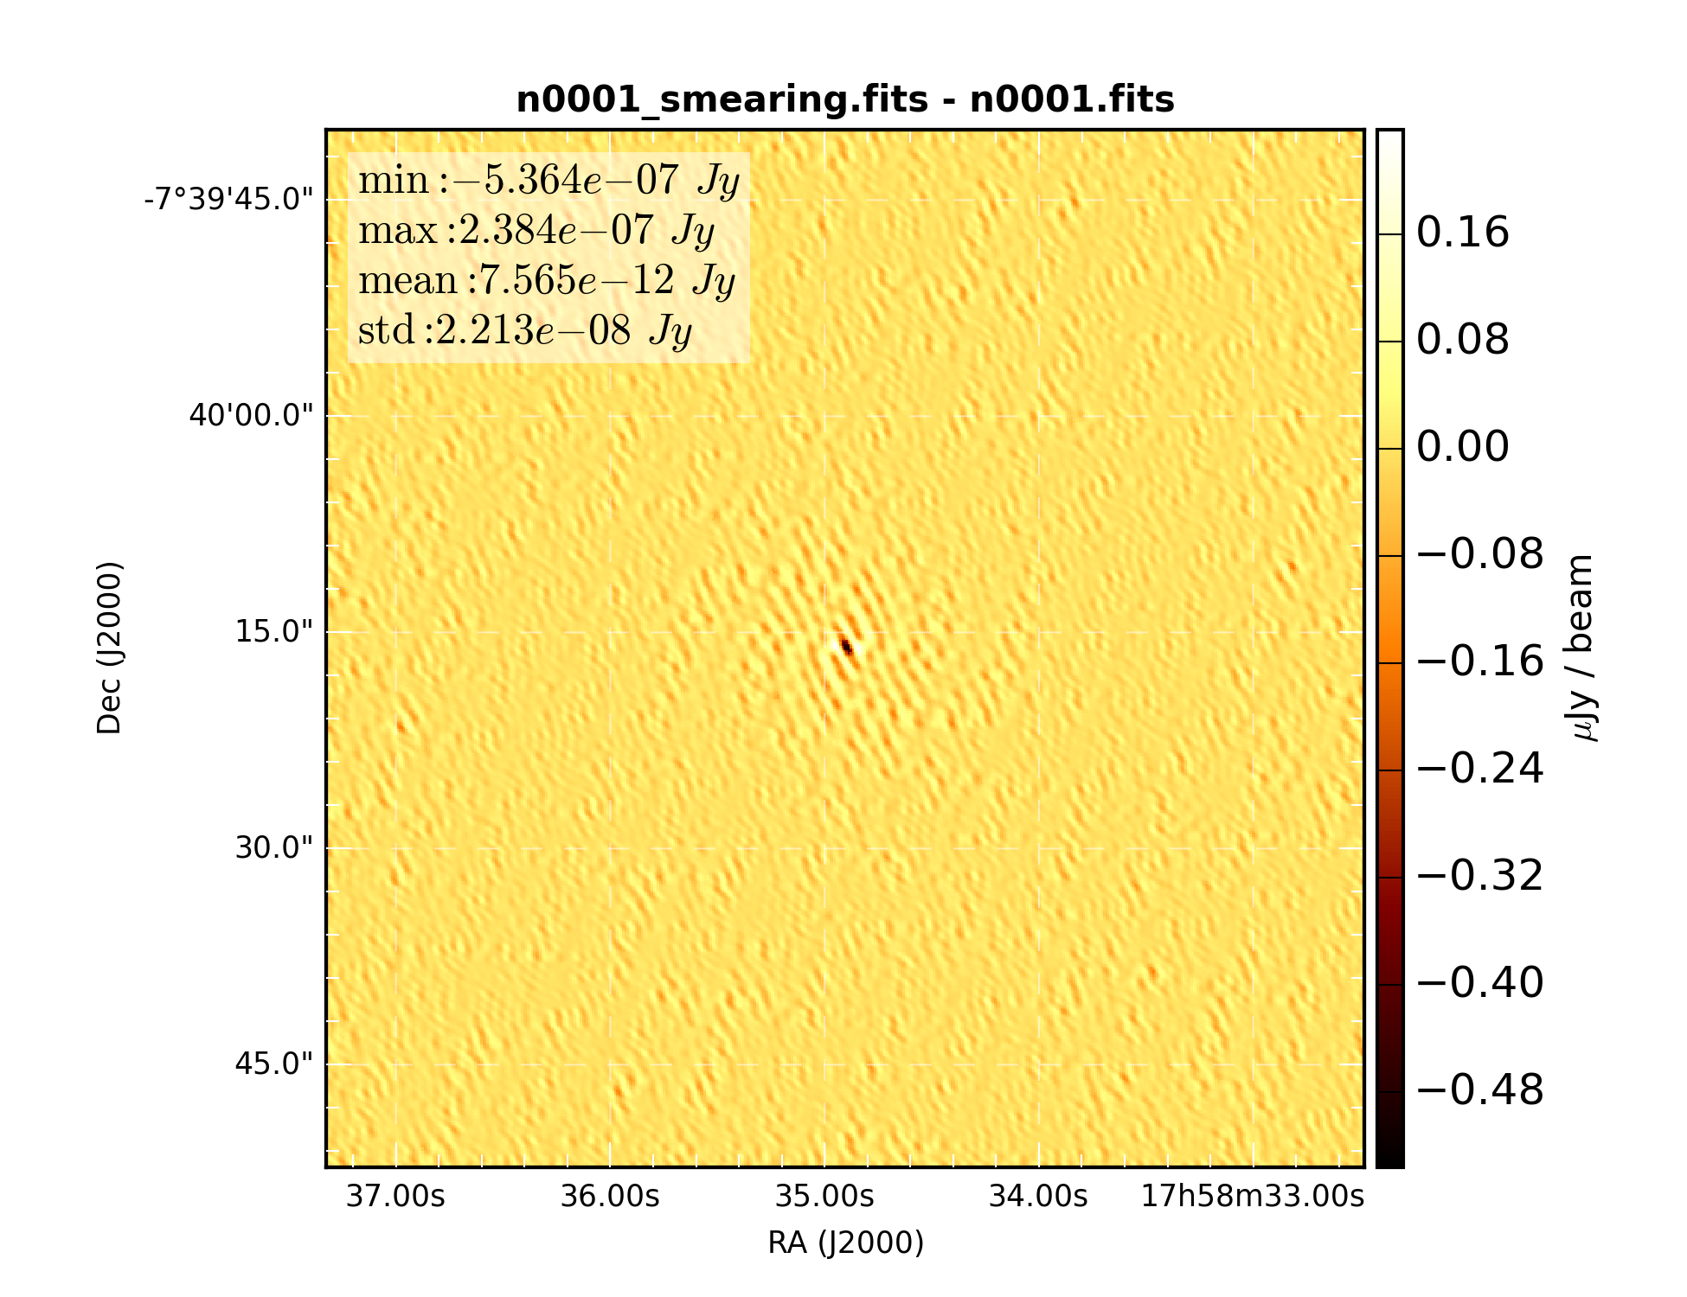

Figure 4: Difference of snapshot dirty images with and without time smearing correction

### Average of 10 snapshots

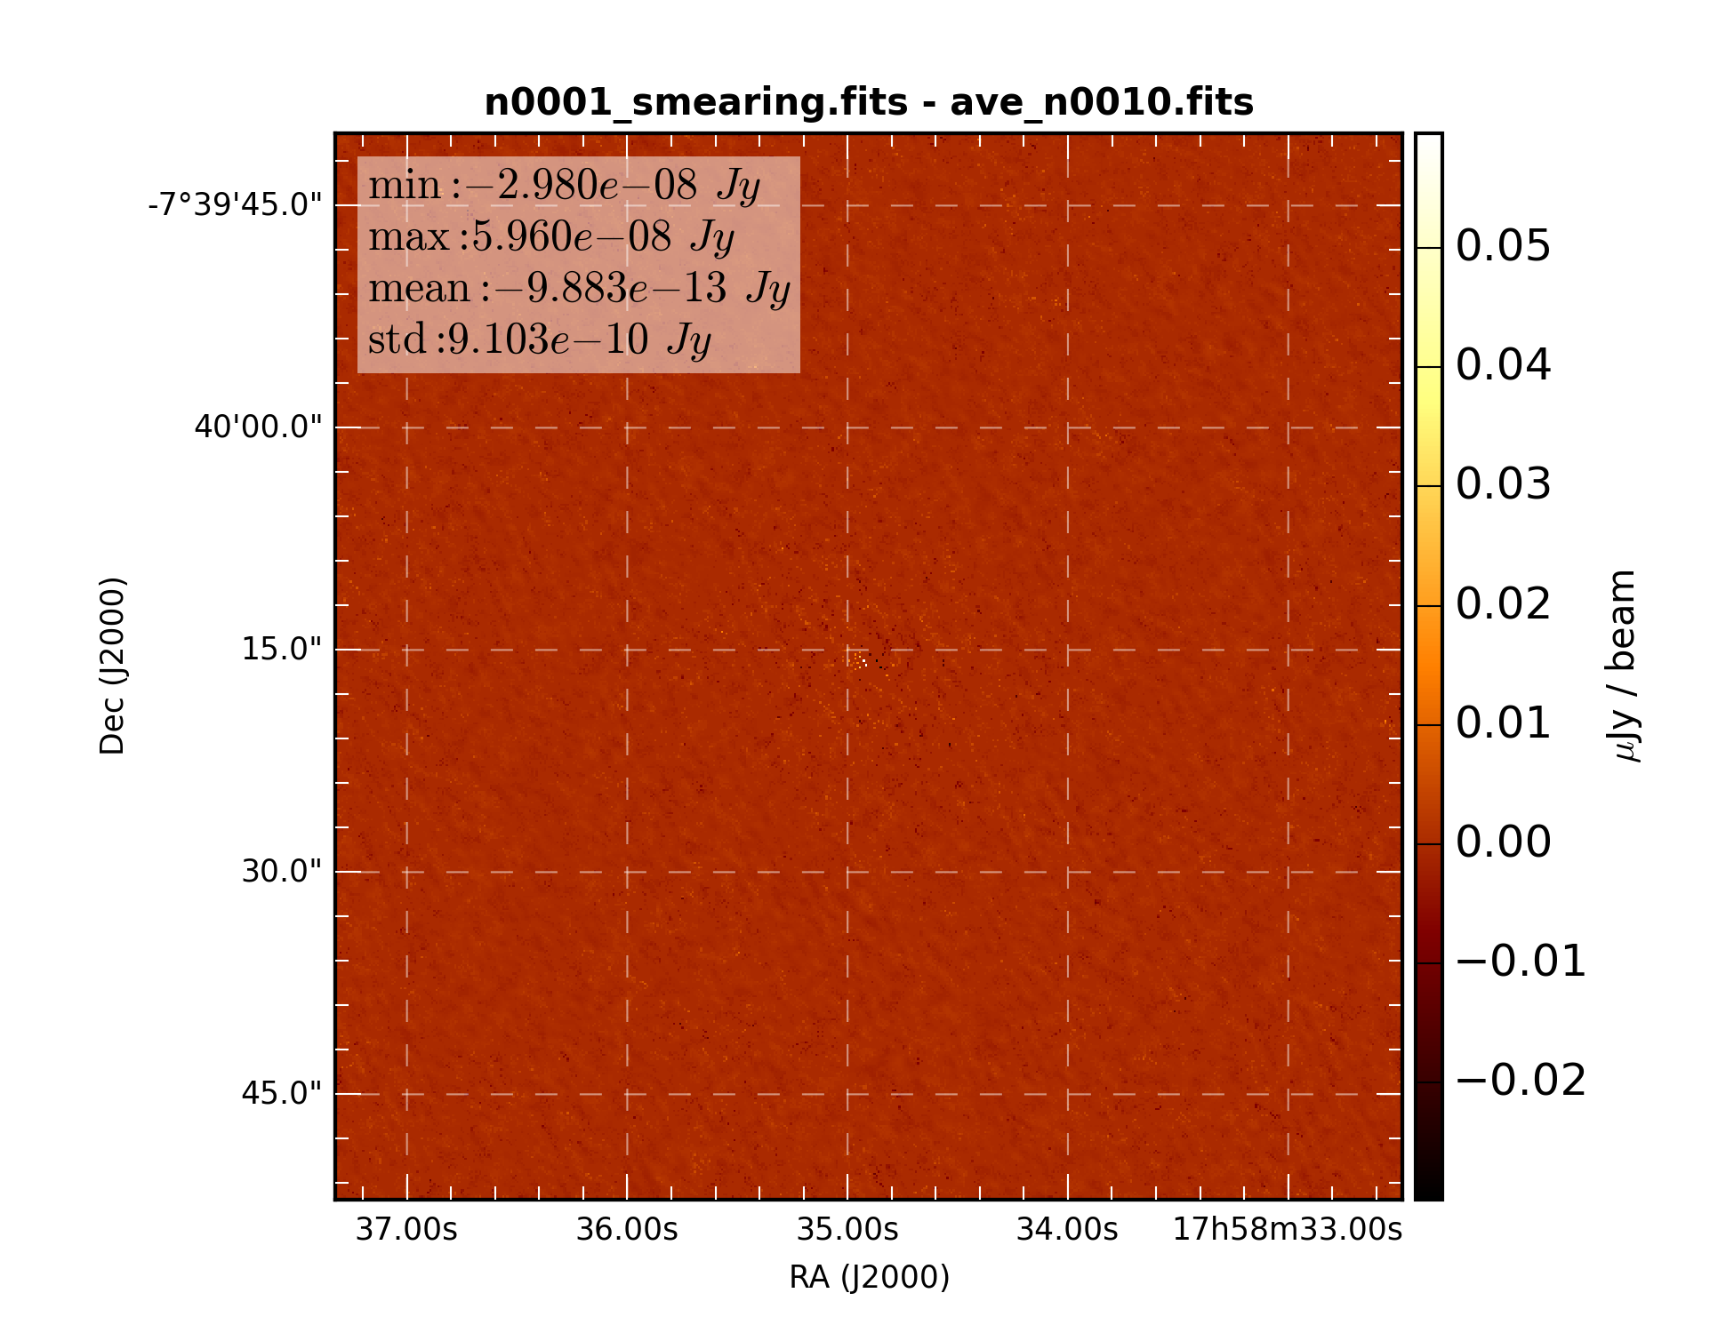

Figure 5: Difference of snapshot dirty image with average of 10 sub-samples.

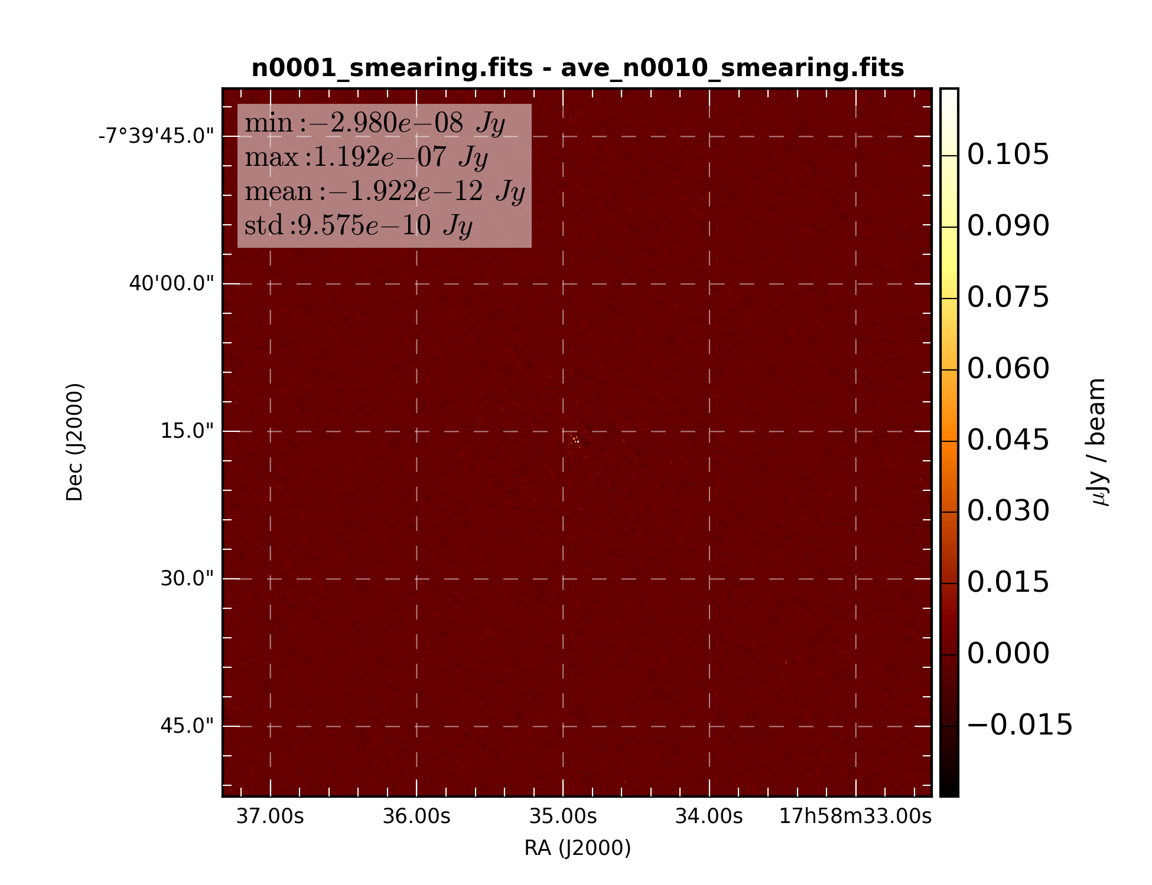

Figure 6: Difference of snapshot dirty image with average of 10 time smearing corrected sub-samples.

### Average of 1000 snapshots

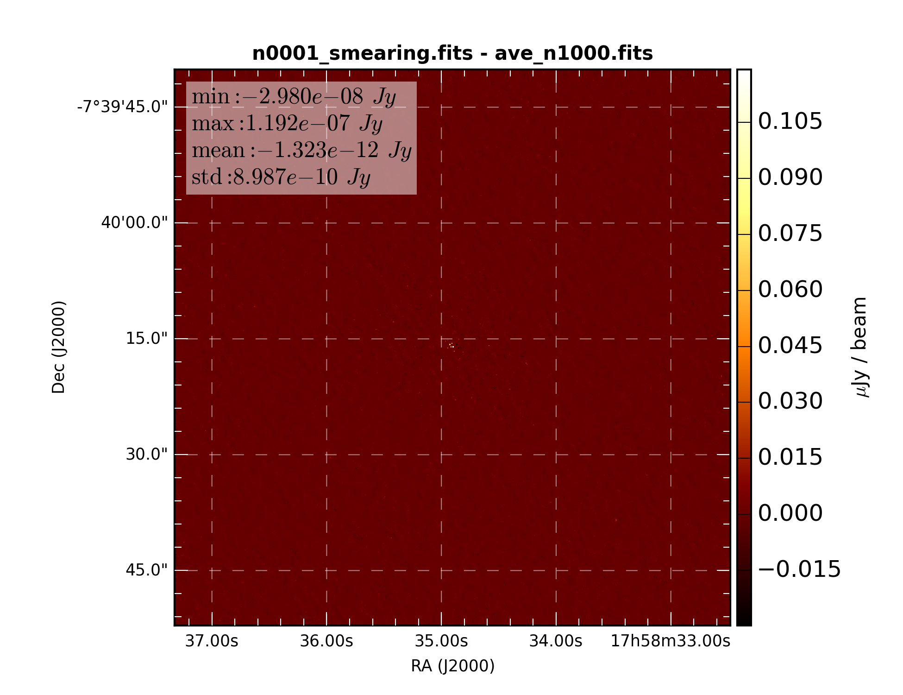

Figure 7: Difference of snapshot dirty image with average of 1000 sub-samples.

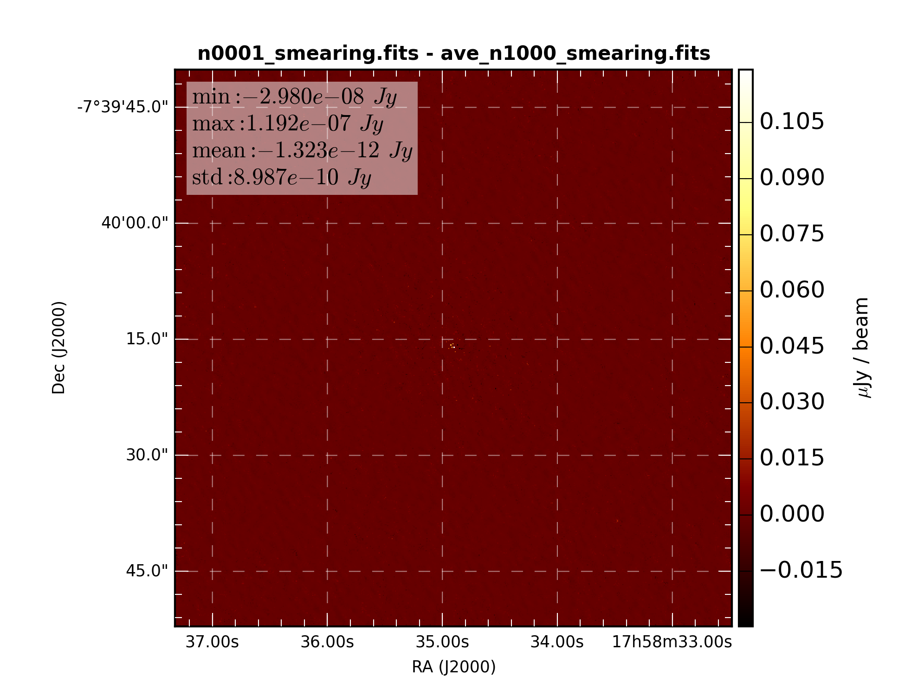

Figure 8: Difference of snapshot dirty image with average of 1000 time smearing corrected sub-samples.

## Simulation 2: 0.1 second correlator dump time

### 1 snapshot

### 10 snapshots

### 1000 snapshots

## Simulation 3: 0.25 second correlator dump time

### 1 snapshot

### 10 snapshots

### 1000 snapshots

## Simulation 4: 0.5 second correlator dump time

### 1 snapshot

### sim04/diff_n0001.png

### Average of 10 snapshots

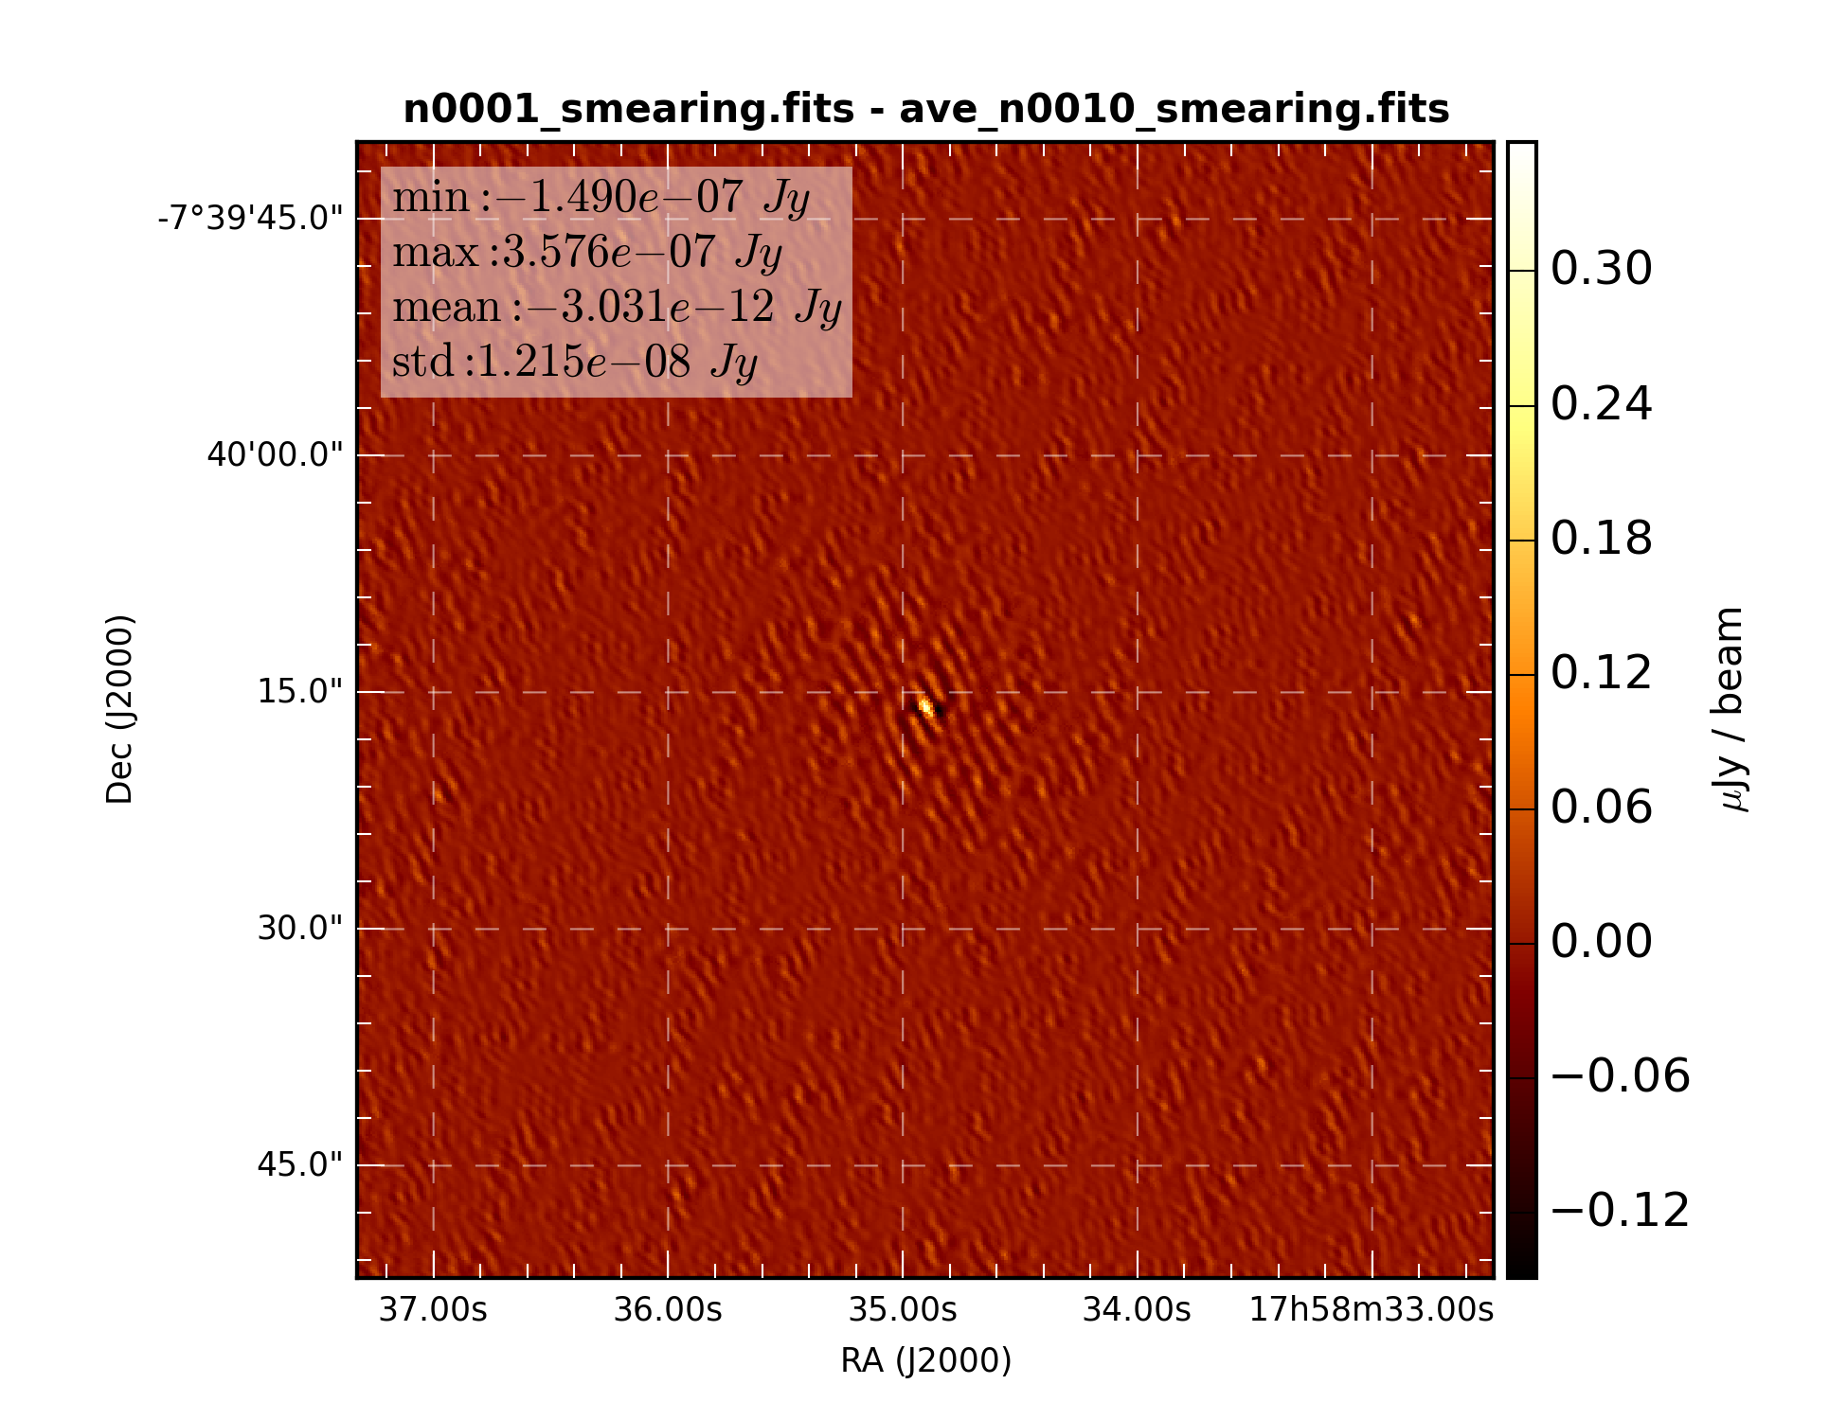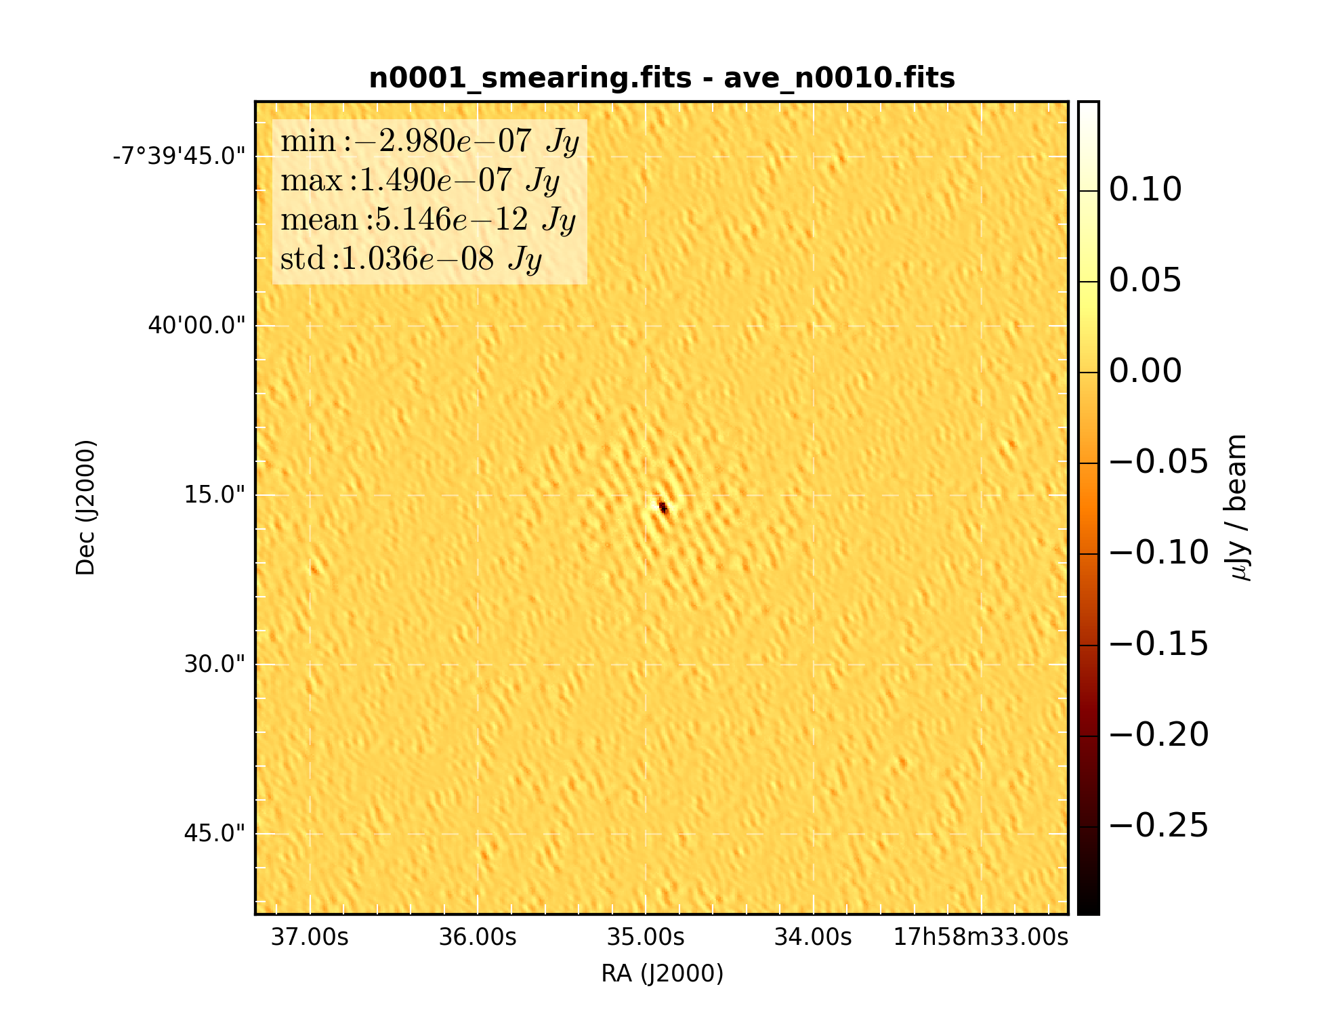

### Average of 1000 snapshots

